**A**

**MINOR PROJECT REPORT ON**

**“INTERNATIONAL CARGO TRACKING SYSTEM”**

*Submitted in partial fulfillment of the requirements*

*for the award of the degree of*

**BACHELOR OF ENGINEERING**

IN

**COMPUTER SCIENCE AND ENGINEERING**

**Submitted to**



**RAJIV GANDHI PROUDYOGIKI VISHWAVIDYALAYA,**

**BHOPAL (M.P.)**

Submitted by

Arti Mittal 0905CS131036

Babita Khanduja 0905CS131053

Under the Guidance of

**PROF. Yogendra S. Rathore**



**DEPARTMENT OF COMPUTER SCIENCE AND ENGINEERING**

**INSTITUTE OF TECHNOLOGY AND MANAGEMENT, GWALIOR**

**June, 2016**

**DECLARATION**

We hereby declare that the Project entitled “**INTERNATIONAL CARGO TRACKING SYSTEM**” is our own work conducted under the supervision of **Mr. Yogendra S. Rathore, Department of Computer Science and Engineering** at **Institute Of Technology And Management, Gwalior.**

We further declare that to the best of our knowledge this report does not contain any part of work that has been submitted for the award of any degree either in this university or in other university without proper citation.

Arti Mittal 0905CS131036

Babita Khanduja 0905CS131053

**CERTIFICATE**

This is to certify that the work embodied in this project entitled **“INTERNATIONAL CARGO TRACKING SYSTEM**” being submitted by **Arti Mittal (0905CS131036), Babita Khanduja (0905CS131053),** in partial fulfillment of the requirement for the award of the degree of the **Bachelor of Engineering (Computer Science & Engineering )** to Rajiv Gandhi Proudyogiki Vishwavidyalaya, Bhopal (M.P.) is a record of bonafide piece of work, carried out by them under our supervision and guidance in the **Department of computer science and engineering**, **Institute Of Technology And Management ,Gwalior(M.P.)**

**Guided By Approved By**

Mr. Yogendra S. Rathore Dr. Rishi Soni

Assistant Professor HOD

Department of Computer Science Department of Computer Science

ITM, Gwalior (M.P.) ITM, Gwalior (M.P.)

**ABSTRACT**

**INTERNATIONAL CARGO TRACKING SYSTEM**

Tracking system is an online system developed for the Movers Ltd. Company. This system solves almost all the limitations of the conventional system. Both the customer and the company are equally benefited by the proposed system. The system saves a lot of time and effort for both.

The system comprises of 3 modules they are Administrator, Staff and Customer. Only the administrator has the rights to enter in to all the modules. He is the only person who has the full control over the system. But others can enter only to their corresponding modules that is for customer module is for customer and staff.

The project is developed using Eclipse as front end and MY SQL Administrator as back end.

**ACKNOWLEDGEMENT**

It gives me immense pleasure to express my deepest sense of gratitude and sincere thanks to my highly respected and esteemed guide **Mr. Yogendra S. Rathore , Department of Computer Science and Engineering** at **Institute Of Technology And Management, Gwalior,**  for their valuable guidance, encouragement and help for completing this work. Their useful suggestions for this whole work and co-operative behavior are sincerely acknowledged.

I would like to express my sincere thanks to **Dr. B K Singh, Director** of **Institute of Technology And Management, Gwalior** for giving me this opportunity to undertake this project.

I also wish to express my gratitude to **Dr. Rishi Soni , HOD, Computer Science and Engineering** for his kind hearted support.

At the end I would like to express my sincere thanks to all my friends and others who helped me directly or indirectly during this project work.

**TABLE OF CONTENTS**

|  |  |  |
| --- | --- | --- |
| **Chapter** | **Table Of content** | **Page No.** |
| Chapter 1 | Introduction   * 1. Aim and Objective | 1 |
| Chapter 2 | Project / Problem Selection  2.1 Purpose of the project  2.2 Project objective  2.3 Scope of the project | 2 |
| Chapter 3 | System Study  3.1 Existing System along with limitations/deficiencies  3.2 Proposed system along with intended objectives  3.3 Feasibility study  3.3.1Technical  3.3.2 Operational  3.3.3Economic | 3 |
| Chapter 4 | System Analysis  4.1Requirement Specification  4.1.1 Hardware Requirements  4.1.2 Software Requirements  4.2 Software Analysis  4.2.1 Activity Diagram  4.2.2 Physical DFD  4.2.3 Logical DFD  4.2.4 Class Diagram | 7 |
| Chapter 5 | Logical And Physical Design Of System  5.1 No. of Modules  5.2 Database Design  5.3 Layouts | 12 |
| Chapter 6 | System Testing  6.1 Test Case Diagram  6.1.1 Black Box Testing  6.1.2 White Box Testing  6.2 Test Execution  6.2.1 Unit Testing  6.2.2 Integration Testing  6.2.3 Validation Testing | 19 |
| Chapter 7 | Bibliography and Web References | 23 |

**CHAPTER 1**

**INTRODUCTION**

**1.1 AIM AND OBJECTIVE:**

**International Cargo Tracking System** is an automated version of manual freight management system.

In case of company, they can save a lot of time, money and manpower. Almost all the work is computerized. So the accuracy is maintained. Maintaining backup is very easy. It can do with in a few minutes. An additional facility for tracking and knowing the status of the parcel is added. Customer can make payments through DD, credit cards etc.

The system has **three levels of interaction** or three **modules**:

1. **Administrator level**
2. **Staff level**
3. **Customer level**

**Administrator level:** From the name itself we know that it is administrator's part. Only the administrator is authorized to log in to it. If any changes is needed in the system, he enter this level and will make enough changes .He is the only authorized person to alter the details in database and other important areas of the system. The updating of the details and other details are edited by him. If a new checkpoint is introduced he will add to the checkpoint list. If new routes are found they also added to the route list.

**Staff level:** This is for the staffs working at the various checkpoints or branches. Staff will log- in using the user id and password. Staff will enter the details of customer and goods while booking .Updating the arrival list and other jobs are done by the customer .Dispatch list are also updated by staffs.

**Customer level:** He can register, if registration is completed, he is provided with tracking id and using this he can know the status of the consignment.

So as aim of developing this project we have some highlights:-

* It will save money of consigner.
* It will save time also.

**CHAPTER 2**

**PROJECT/PROBLEM SELECTION**

**2.1 PURPOSE OF THE PROJECT:**

Purpose of this website is to provide goods transformation service for consigner and online services to the users to know about the current status of their product.

This website provides all the services at very low cost. Our purpose behind the development of this website is that as we all know that people are going to busy in their works so much and they have no time to shipping the product, so our website will help these kind of busy people to shipping their desire products. And also there are lots of people in the world who are the real user of this kind of facility.

**2.2 PROJECT OBJECTIVE:**

In case of company, they can save a lot of time, money and manpower. Almost all the work is computerized. So the accuracy is maintained. Maintaining backup is very easy. It can do with in a few minutes. An additional facility for tracking and knowing the status of the parcel is added. Customer can make payments through DD, credit cards etc.

**2.3 SCOPE OF THE PROJECT:**

International Cargo Tracking System is “the incorporate of appropriate technology to help administrator manage information. Technology is considered appropriate, when it utilizes the most abundant domestic resources and conserves capital and skilled personnel”.

This project deals with the maintenance of booking details, incoming courier details, courier non delivery details and courier return details etc.; the main aim of this project is to computerize the maintenance of courier management.

**CHAPTER 3**

**SYSTEM STUDY**

**3.1 EXISTING SYSTEM**

The existing system is a manual one which needs a lot of paper works that consumes more time, money and human effort. Searching is also difficult when they are manually processed. Recovery of data lost by accidental damage of stored papers is not possible in the present system. Taking hard copy backups consumes extra time and money.

The existing system is subjected to close study and the problem areas are identified. The solutions are given as a proposal. The proposal is then weighed with the existing system analytically and the best one is selected. The proposal is presented to the user for endorsement. The current system will do all the steps manually. The customers have to come to office for booking and handing over the parcel. It will need a lot of effort and time. Every work should be done manually. Each transaction has to be entered manually. Since there are a lot of transactions occurring daily, it's time consuming and also generates a lot of workload. Shortest path for the consignment cannot be calculated. There is no provision for tracking the path for both customers and staffs. At the time of booking it is not easy to select the shortest path that benefits the customer. It is difficult to select the shortest path between the source and destination manually. Existing system needs more employees for the work .It is a risky job to search a record for editing or any other purposes .Updating the records are difficult and time consuming. Once the customer has handed over the parcel, it's difficult to know where it is until it reaches the destination. Customer has to wait for the acknowledgment from the destination branch to know about the safe delivery. Customer has to pay the service charge by cash. Under the current system there is no other means of payment.

**Drawbacks of Existing System**

The main drawback of the system is its manual environment. It will lead's to a lot of workload and complexities. It requires more man power. There is no online facility for tracking or payment.

**Important drawbacks**

* Manual booking leads to a lot of paper works.
* More man power is required.
* Customer has to come to office for booking.
* Selection of shortest path is difficult which leads to wastage of time and money.
* Tracking of goods is not possible.
* Credit card or online payment is not possible, only cash payment is possible.

**3.2 PROPOSED SYSTEM**

The proposed system is a solution for the above mentioned problems. Almost all the work is automated .So the manpower and the workload is considerably reduced. Since it is an online system the customer is equally benefited along with the service provider. If the Customer can make use of the facilities provided ,he can save a lot of money and time .He need not come to office for booking and to hand over the parcel. He can book online and register using the online system .He can make the payment through credit cards and other online banking system.

During booking customer is given a booking id .He can use this id to log in the website for current status of the cargo. If it is an overseas shipment it is very useful and cost-effective method to track the details. Customer can select the path using the GUI which will cut the cost and time .If we take the company side they have many benefits. All the manual work is computerized .A lot of man power and time is saved .Since the conventional system has a lot of paper works, it is very risky and error prone .Proposed system is user friendly and transactions are recorded accurately. Searching the records and editing is very easy.

**3.3 FEASIBILITY STUDY:**

System analysis is the process of identification of the objectives and requirements, evaluation of alternative solutions and recommendation for a more feasible solution. In other words, system analysis is the step-by-step process of gathering, recording and interpreting facts. It is the reduction of an entire system by studying the various operations. It includes studying the problems encountered in the present system and introducing a new computer system into an organization

The feasibility study is carried out to select the best system that meets performance requirement. Feasibility study is used to determine of whether or not a project is work doing. This process followed in making this determine called feasibility study. This type of study determines if a project can and should be taken.

The key considerations are invoked in the feasibility invoke analysis are:

* Technical Feasibility
* Economic Feasibility
* Operational Feasibility

**3.3.1 TECHNICAL FEASIBILITY:**

Technical Feasibility centers on the existing computer system (hardware/ software) and also it can support the modification. In manual processing there are more chances of errors, creating lot of complications, less technical or logical. Through proposed system we can set this process in a very systematic pattern, which is more technical, full proof, authentic, safe and reliable.

**For example**, if the current computer is operating at 80 percent capacity - an arbitrary ceiling - then running another application could overload the system or require additional Hardware. This involves financial considerations to accommodate technical enhancements. If the budget is a serious constraint, then the project judged is not feasible. In this project, all the necessary cautions have been taken care to make it technically feasible. Using a key the display of text/object is very fast. Also, the tools, operating system and programming language used in this localization process is compatible with the existing one.

**3.3.2** **OPERATIONAL FEASIBILITY:**

Operational feasibility is mainly related to the human organizational & political aspects. This feasibility study answers questions like: Will the system be used if it is developed and implemented? Will there be resistance from users that will undermine the possible application benefits?

To get the answer of these questions, many methods are used like interviews, questionnaire, records checking and observation. This feasibility study is generally carried out by one or two persons who are familiar with information system techniques, who understands the business and who are skilled in system analysis and design.

The essential questions that help in testing the operational feasibility of a system as follows:

* What changes will be made in the system?
* What organizational structures are?
* What new skills will be required? Do the existing staff members have these skills? If not, can they be trained in due course of time?
* Operational feasibility study is carried out by a small group of people who are familiar with information system technique who understand the parts of the business that are relevant to the project and are skilled in system analysis and design process?

The feasibility study is carried out by a small group of people who are familiar with information system techniques, understand the part of business or organization that will be involved or affected by a project, and are skilled in the system analysis & design process

Operational feasibility is the mainly related to the human organizational. This feasibility study answers question like:

* Will the system we used if it is developed and implemented?
* Will there be resistance from users that will undetermined the possible application benefit. This application is extensible..

**3.3.3 ECONOMICAL FEASIBILITY:**

Economic analysis is the most frequently used method for evaluating the effectiveness of the candidate system. More commonly known as cost/benefit analysis, the procedure is to be determining the benefits and savings that are expected from a candidate and compare them with costs. If benefits outweigh costs, then the decision is made to design and implement the system.

A systems financial benefit must exceed the cost of developing that system. i.e. a new system being developed should be a good investment for the organization. Economic feasibility considers the following:

* The cost to conduct a full system investigation.
* The cost of hardware and software for the class of application.
* The benefits in the form of reduced cost or fewer costly errors.
* The cost if nothing changes (i.e. the proposed system is not developed)

**CHAPTER 4**

**SYSTEM ANALYSIS**

**4.1 REQUIREMENT SPECIFICATION**

## **4.1.1 HARDWARE REQUIREMENT:**

|  |  |  |
| --- | --- | --- |
| RAM | **:** | 1 GB (or above) |
| Hard Disk | **:** | 40 GB (or Above) |
| Processor | **:** | System with Pentium Processor |

**4.1.2 SOFTWARE REQUIREMENT:**

|  |  |  |
| --- | --- | --- |
| Operating system | **:** | window XP, 7(or above) |
| Front End | **:** | Eclipse(HTML, Java Script) |
| Back End | **:** | My SQL |
| Application Server | **:** | Web Browser |
| Client Programming | **:** | HTML |
| Connectivity | **:** | JDBC |
| Server | **:** | Apache tomcat 7.0,Servlet,JSP  **3.3 Software Analysis** |

**4.2 SOFTWARE ANALYSIS**

**4.2.1 ACTIVITY DIAGRAM**

**4.2.2 PHYSICAL DFD**

Consigner

Goods Information

Employee

Enquiry

Enquiry Report

Display Tracking Information

Tracking Information

**4.2.3 LOGICAL DFD**

Employee Database

Tracking Id

Goods Information

Consigner Database

Consigner

Enquiry

Employee

Tracking Database

**4.2.4 CLASS DIAGRAM**

Employee:-

Emp id

Emp Name

Emp Fname

Gender

DOB

Address

City

State

Country

Phone No

Email Id

Photo

Password

Enquiry:-

Emp Id

Enquiry no.

Date of Query

Track No

Description

Action

1:*

*:*

Goods Information:-

Tracking Id

Current date

Type of goods

Goods Description

No. of Packets

Weight of Packet

Price

Invoice Copy

Status of Goods

Dispatch date

Consigner:-

Consigner ID Email Id

Firm Name Mobile No

Consigner Name

Address

City

State

Country

Zip code

Company Registration

Company Regis Pic

Consigner:-

Consigner ID Email Id

Firm Name Mobile No

Consigner Name

Address

City

State

Country

Zip code

Company Registration

Company Regis Pic

Tracking Information:-

Tracking ID

Current Date

Description

Tracking Information:-

Tracking ID

Current Date

Description

*:*

1:*

Consigner:-

Consigner ID Email Id

Firm Name Mobile No

Consigner Name

Address

City

State

Country

Zip code

Company Registration

Company Regis Pic

Consigner:-

Consigner ID Email Id

Firm Name Mobile No

Consigner Name

Address

City

State

Country

Zip code

Company Registration

Company Regis Pic

1:*

**CHAPTER 5**

**LOGICAL AND PHYSICAL DESIGN OF SYSTEM**

**System Design:** System design is an important step in any project. There is a variety of ways by which the system can be designed. Here the system has been developed using the top down integration approach. This technology integrates analyzing, designing, coding and testing which are the software designing concepts. The design proceeds from highest level. Top down technique provides an orderly and systematic framework to the project.

**Input Design:** Input design is the process of converting user-originated inputs to a computer based format, Input data are collected and organized into a group of similar data. Inaccurate input data is the most common cause of data processing errors. Effective input design minimizes errors made by data entry operators. The goal of designing input data is to make data entry as easy, logical and free from errors as possible.

**Output Design:** Computer output is the important and direct source of information to the user. Efficient, Intelligible Output design should improve the system's relationships with the user and helps in decision making. They also provide a permanent hard copy of these results for later consultation.

**Logical Design:** The DFD so far are known as logical data flow diagrams. They specify various logical processes performed on data, i.e. the type of operations performed. A logical DFD does not specify who does the operations, whether it is done manually or with a computer and also where it is done. A physical DFD specifies these.

**Physical Design:** A physical DFD is easily drawn the fact gathering stage. A physical DFD is a good starting point in developing logical DFD; it is sometimes useful to depict physical movement of materials.

The data flow diagram shows the logical flow of a system and defines the boundaries of the system. For a candidate system, it describes the inputs (source), outputs (destination), database (files) and procedures (data flow), all in a format that meet the user's requirements.

**5.1 NO. OF MODULES**

This project includes the following modules for development of the project. These are as follows: -

1. **ADMIN LOGIN FORM:** This form shows the Login name and password when admin enter a valid admin name and password then he/she can operate the application.
2. **ADMIN HOME:** This form is a menu-based form that displays the menu for operation of the application. It includes insert employee record, logout etc.
3. **EMPLOYEE LOGIN FORM:** This form shows the Login name and password when employee enters a valid employee name and password then he/she can operate the application.
4. **EMPLOYEE HOME:** This form is a menu-based form that displays the menu for operation of the application. It includes insert consigner, consignee, goods, tracking information & logout etc.
5. **TRACKING FORM:** This form display current status about the products.

**5.2 DATABASE DESIGN**

1. **Table Name - Admin**

|  |  |
| --- | --- |
| **Column Name** | **Datatype** |
| Adminid | Varchar(45) |
| Password | Varchar(45) |

1. **Table Name – City**

|  |  |
| --- | --- |
| **Column Name** | **Datatype** |
| Cityid | Varchar(45) |
| Stated | Varchar(45) |
| Name | Varchar(45) |

1. **Table Name – Communication**

|  |  |
| --- | --- |
| **Column Name** | **Datatype** |
| Communicationid | INT(10) |
| Trackingid | INT(10) |
| date_time | Varchar(45) |
| Employeeid | Varchar(45) |
| Description | Varchar(45) |

1. **Table Name – Consignee**

|  |  |
| --- | --- |
| **Column Name** | **Datatype** |
| Consigneeid | Varchar(45) |
| Name | Varchar(45) |
| registrationNo | DOUBLE |
| IENo | DOUBLE |
| Address | Varchar(45) |
| Country | Varchar(45) |
| State | Varchar(45) |
| City | Varchar(45) |
| Email | Varchar(45) |
| mobileNo | Varchar(45) |
| Description | Varchar(45) |

1. **Table Name - Consigner**

|  |  |
| --- | --- |
| **Column Name** | **Datatype** |
| Consigneeid | Varchar(45) |
| Name | Varchar(45) |
| registrationNo | DOUBLE |
| IENo | DOUBLE |
| Address | Varchar(45) |
| Country | Varchar(45) |
| State | Varchar(45) |
| City | Varchar(45) |
| Email | Varchar(45) |
| mobileNo | Varchar(45) |
| Description | Varchar(45) |

1. **Table Name – Country**

|  |  |
| --- | --- |
| **Column Name** | **Datatype** |
| Countryid | Varchar(45) |
| Name | Varchar(45) |

1. **Table Name – Dispatch**

|  |  |
| --- | --- |
| **Column Name** | **Datatype** |
| Trackingid | INT(10) |
| Productid | Varchar(45) |
| Consigneeid | Varchar(45) |
| Consignerid | Varchar(45) |
| Dateofdipatch | Varchar(45) |
| Portname | Varchar(45) |
| airline_shipno | Varchar(45) |
| Description | Varchar(45) |

1. **Table Name-Employee**

|  |  |
| --- | --- |
| **Column Name** | **Datatype** |
| employeeId | Varchar(45) |
| Employeename | Varchar(45) |
| employeeGender | Varchar(45) |
| employeeDOB | Varchar(45) |
| Address | Varchar(45) |
| Country | Varchar(45) |
| State | Varchar(45) |
| City | Varchar(45) |
| email_Id | Varchar(45) |
| mobileNo | Varchar(45) |
| Password | Varchar(45) |

1. **Table Name – Product**

|  |  |
| --- | --- |
| **Column Name** | **Datatype** |
| productId | Varchar(45) |
| productCompany | Varchar(45) |
| productName | Varchar(45) |
| productModel | Varchar(45) |
| productType | Varchar(45) |
| productRate | FLOAT |
| qtyDispatch | INT(10) |
| noOfPackets | INT(10) |
| qtyInPacket | Varchar(45) |
| dimAndWeight | Varchar(45) |

1. **Table Name – State**

|  |  |
| --- | --- |
| **Column Name** | **Datatype** |
| Stated | Varchar(45) |
| Countryid | Varchar(45) |
| Name | Varchar(45) |

1. **Table Name – Tracking**

|  |  |
| --- | --- |
| **Column Name** | **Datatype** |
| Employeeid | Varchar(45) |
| Trackingid | INT(10) |
| Trackingdate | Varchar(45) |
| Description | Varchar(45) |

* 1. **LAYOUTS**

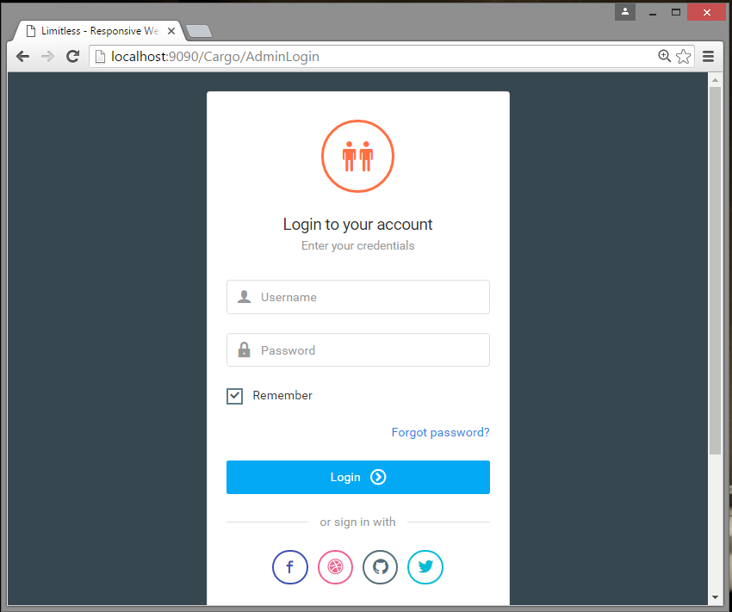

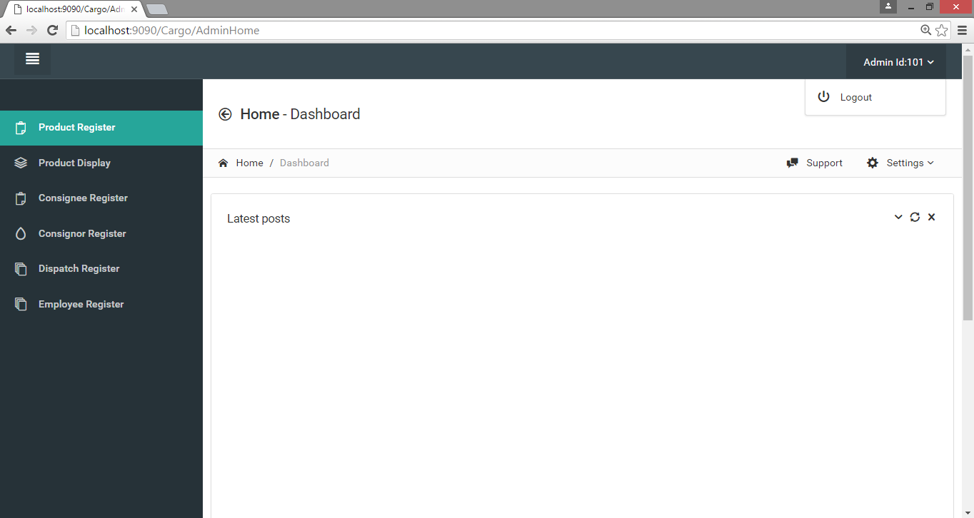

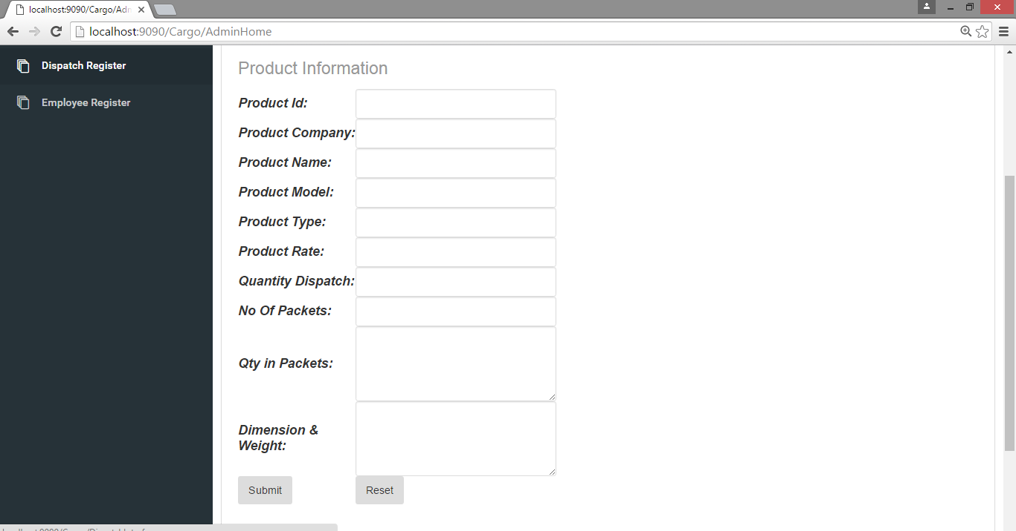

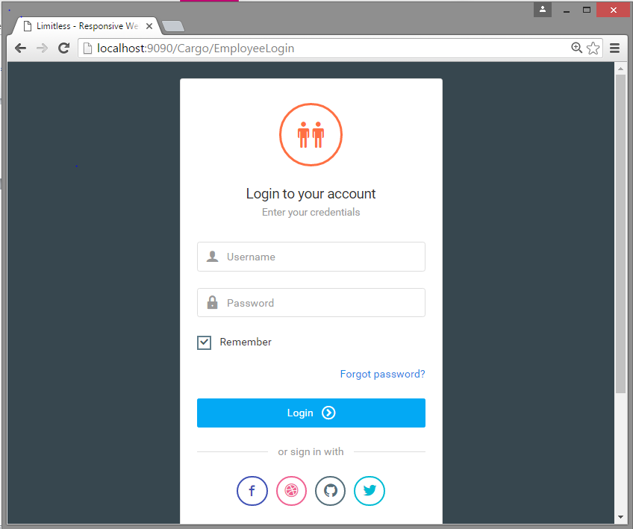

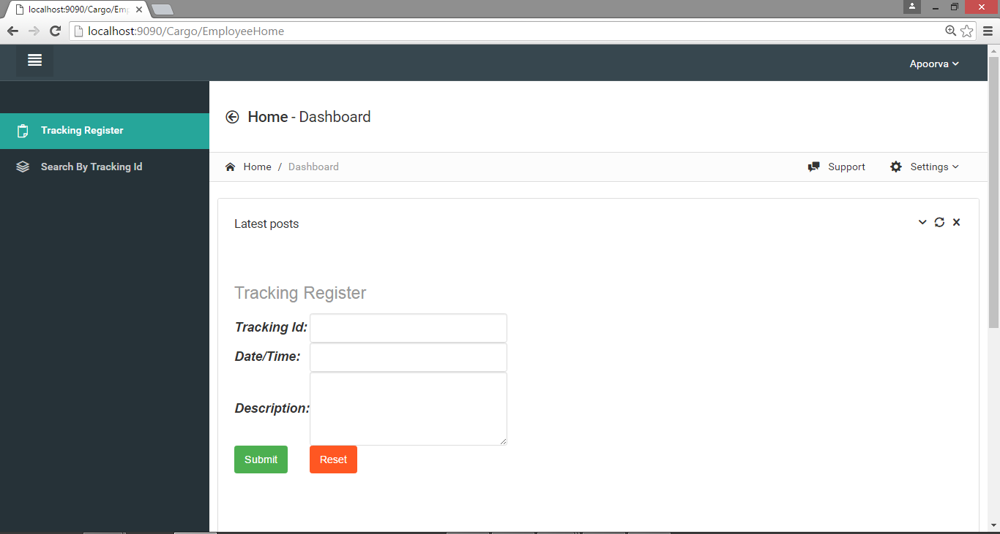

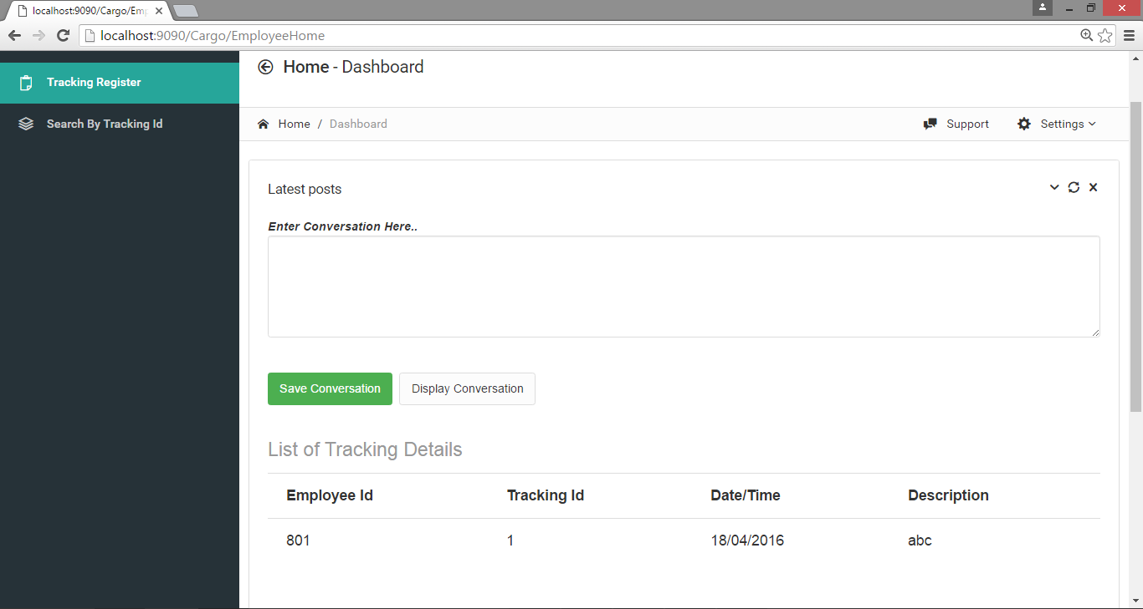

**CHAPTER 6**

**SYSTEM TESTING**

**6.1 TEST CASE DESIGN**

**6.1.1 BLACK BOX TESTING:**

The technique of testing without having any knowledge of the interior workings of the application is Black Box testing. The tester is oblivious to the system architecture and does not have access to the source code. Typically, when performing a black box test, a tester will interact with the system's user interface by providing inputs and examining outputs without knowing how and where the inputs are worked upon.

**Black-box testing** is a method of [software testing](http://en.wikipedia.org/wiki/Software_testing) that examines the functionality of an application (e.g. what the software does) without

peering into its internal structures or workings. This method of test can be applied to virtually every level of software testing: [unit](http://en.wikipedia.org/wiki/Unit_test), [integration](http://en.wikipedia.org/wiki/Integration_testing), [system](http://en.wikipedia.org/wiki/System_testing) and [acceptance](http://en.wikipedia.org/wiki/Acceptance_test). It typically comprises most if not all higher level testing, but can also dominate [unit testing](http://en.wikipedia.org/wiki/Unit_testing) as well

**6.1.2 WHITE BOX TESTING:**

White box testing is the detailed investigation of internal logic and structure of the code. White box testing is also called glass testing or open box testing. In order to perform white box testing on an application, the tester needs to possess knowledge of the internal working of the code.

**white-box testing** (also known as **clear box testing**, **glass box testing**, **transparent box testing**, and **structural testing**) is a method of testing [software](http://en.wikipedia.org/wiki/Software) that tests internal structures or workings of an application, as opposed to its functionality (i.e. [black-box testing](http://en.wikipedia.org/wiki/Black-box_testing)). In white-box testing an internal perspective of the system, as well as programming skills, are used to design test cases. The tester chooses inputs to exercise paths through the code and determine the appropriate outputs. This is analogous to testing nodes in a circuit, e.g. [in-circuit testing](http://en.wikipedia.org/wiki/In-circuit_test) (ICT).

While white-box testing can be applied at the [unit](http://en.wikipedia.org/wiki/Unit_testing), [integration](http://en.wikipedia.org/wiki/Integration_testing) and [system](http://en.wikipedia.org/wiki/System_testing) levels of the [software testing](http://en.wikipedia.org/wiki/Software_testing) process, it is usually done at the unit level. It can test paths within a unit, paths between units during integration, and between subsystems during a system–level test. Though this method of test design can uncover many errors or problems, it might not detect unimplemented parts of the specification or missing requirements.

**6.2 TEST EXECUTION:**

**6.2.1 UNIT TESTING**

Unit testing is a way of testing software components. The "Unit" is the thing being tested. You can do both black and white box testing with unit tests; the concept is orthogonal to white/black-box testing.

The developer carries out unit testing in order to check if the particular module or unit of code is working fine. The Unit Testing comes at the very basic level as it is carried out as and when the unit of the code is developed or a particular functionality is built.

Unit testing deals with testing a unit as a whole. This would test the interaction of many functions but confine the test within one unit. The exact scope of a unit is left to interpretation. Supporting test code, sometimes called scaffolding, may be necessary to support an individual test. This type of testing is driven by the architecture and implementation teams. This focus is also called black-box testing because only the details of the interface are visible to the test.

Limits that are global to a unit are tested here. In the construction industry, scaffolding is a temporary, easy to assemble and disassemble, frame placed around a building to facilitate the construction of the building. The construction workers first build the scaffolding and then the building. Later the scaffolding is removed, exposing the completed building.

Similarly, in software testing, one particular test may need some supporting software. This software establishes an environment around the test. Only when this environment is established can a correct evaluation of the test take place. The scaffolding software may establish state and values for data structures as well as providing dummy external functions for the test. Different scaffolding software may be needed from one test to another test. Scaffolding software rarely is considered part of the system. Sometimes the scaffolding software becomes larger than the system software being tested. Usually the scaffolding software is not of the same quality as the system software and frequently is quite fragile.

**6.2.2 INTEGRATION TESTING**

Testing (sometimes called integration and testing, abbreviated I&T) is the phase in [software testing](http://en.wikipedia.org/wiki/Software_testing) in which individual software modules are combined and tested as a group. It occurs after [unit testing](http://en.wikipedia.org/wiki/Unit_testing) and before [validation testing](http://en.wikipedia.org/wiki/Verification_and_validation_%28software%29). Integration testing takes as its input [modules](http://en.wikipedia.org/wiki/Module_%28programming%29) that have been [unit tested](http://en.wikipedia.org/wiki/Unit_testing), groups them in larger aggregates, applies tests defined in an integration [test plan](http://en.wikipedia.org/wiki/Test_plan) to those aggregates, and delivers as its output the integrated system ready for [system testing](http://en.wikipedia.org/wiki/System_testing).

The purpose of integration testing is to verify functional, performance, and reliability [requirements](http://en.wikipedia.org/wiki/Requirement) placed on major design items. These "design items", i.e. assemblages (or groups of units), are exercised through their interfaces using [black box testing](http://en.wikipedia.org/wiki/Black_box_testing), success and error cases being simulated via appropriate parameter and data inputs. Simulated usage of shared data areas and [inter-process communication](http://en.wikipedia.org/wiki/Inter-process_communication) is tested and individual [subsystems](http://en.wikipedia.org/wiki/Subsystem) are exercised through their input interface. [Test cases](http://en.wikipedia.org/wiki/Test_case) are constructed to test whether all the components within assemblages interact correctly, for example across procedure calls or process activations, and this is done after testing individual modules, i.e. unit testing. The overall idea is a "building block" approach, in which verified assemblages are added to a verified base which is then used to support the integration testing of further assemblages.

Some different types of integration testing are [big bang](http://en.wikipedia.org/w/index.php?title=Big_Bang_%28project_management%29&action=edit&redlink=1), [top-down, and bottom-up](http://en.wikipedia.org/wiki/Top-down_and_bottom-up_design). Other Integration Patterns are: Collaboration Integration, Backbone Integration, Layer Integration, Client/Server Integration, Distributed Services Integration and High-frequency Integration.

**6.2.3 VALIDATION TESTING**

The assurance that a product, service, or system meets the needs of the customer and other identified stakeholders. It often involves acceptance and suitability with external customers. Validation is intended to ensure a product, service, or system (or portion thereof, or set thereof) result in a product, service, or system (or portion thereof, or set thereof) that meets the operational needs of the user. For a new development flow or verification flow, validation procedures may involve modelling either flow and using simulations to predict faults or gaps that might lead to invalid or incomplete verification or development of a product, service, or system (or portion thereof, or set thereof). A set of validation requirements (as defined by the user), specifications, and regulations may then be used as a basis for qualifying a development flow or verification flow for a product, service, or system (or portion thereof, or set thereof). Additional validation procedures also include those that are designed specifically to ensure that modifications made to an existing qualified development flow or verification flow will have the effect of producing a product, service, or system (or portion thereof, or set thereof) that meets the initial design requirements, specifications, and regulations; these validations help to keep the flow qualified. It is a process of establishing evidence that provides a high degree of assurance that a product, service, or system accomplishes its intended requirements. This often involves acceptance of fitness for purpose with end users and other product stakeholders. This is often an external process.

It is sometimes said that validation can be expressed by the query "Are you building the right thing?" and verification by "Are you building it right?” "Building the right thing" refers back to the user's needs, while "building it right" checks that the specifications are correctly implemented by the system. In some contexts, it is required to have written requirements for both as well as formal procedures or protocols for determining compliance.

**CHAPTER 7**

**BIBLIOGRAPHY AND WEB REFERENCES**

|  |  |
| --- | --- |
| Database System Concept | Silberschatz.Korth |
| Software Engineering - A practitioner's Approach | Roger S. Pressman |

* [www.http://stackoverflow.com](http://www.http://stackoverflow.com)
* <http://www.javaworld.com>
* <http://www.javatpoint.com/servlet-http-session-login-and-logout-example>
* <http://www.technicaladvices.com/2012/07/08/the-effective-java-logout-servlet-code/>

**System Design-**